اسئلة القواعد

- Don’t take this book. It’s ………………
(mine – her – his – he)

- My teacher used to come to class with him……………
(few pens – some pens)

- If I………….. more time, I many languages.
(have/ learn – had / had learned – had/ would learned)

- Hana: Is that Dare’s?

Ahmed: No, it’s…… (me – my – mine)
- My father was born (at –in– on) June 22, 1988.

- I (think/ am thinking) grammar is easy.

- Look! Khalid about his problem.

(thinks/ is thinking)

- The man… I met last night was happy.
(whom – who – which)

- When the move actress entered the room, everyone turned and looked at !
(herself – hers – her)
- If they enough money , they would have built modern villas.
(had had-had-have)

- If you… Me, I can get full marks.
(teach – teached – had teached)

- I prepare for my project author's books do you recommend
(which – who – that)

- Jenny wasn’t able to come to yesterday meeting. She… Take her mother to the dentist.
(must to – had to – could – would)

- I do it if I could, but I am already busy with something else.
(Will – can – would - shell)

- My Family has lived her last march.
(for – since – in – by)
- She has worked there she finished College.
(for – since – in – by)

17 Some money here.
(there’s – there’re – more)

- I’ve got many problems.
(too – a – enough – really)

- A You do as you are told, you will not be allowed in this class.
B: Ok then, if you insist.
(if only – if – supposing – uncles)
- A: How do you feel?
B: Not good. I wish I that big meal lost night.
(didn’t have – wouldn’t have had – hadn’t had)

- A: would you like to go out to night?
B: Not really, I’d Stay at home and watch TV.
(rather – like – want – prefer)
- A: what happen if all the clocks in land on stopped?
B: I don’t know that a silly question! (do – will – can – would)

- A: was John ready for his exam last week? B: No, he… studied anything at all.
(hasn’t – hadn’t – didn’t – wasn’t)**

- I know the… Name.
(thief’s)

- When I…………… in Cairo, I my family
(arrived / called)
- I do it, if could, but I am already busy with something else (would).

- Nayef makes breakfast while lunch …… by his wife (is made).
- The teacher told the children to the swimming.
(Not to go - No go - Don't go)

- What she said?
She told me. the prescription.
(that l take - to take)

- Where you working before joining his company?
( were – does– was – has)

31 they go to Emma’s party yesterday?
( Did– Do–Does– Were)
- Jeddah Rabigh. It’s a cosmopolitan city.
(the most interesting– is more interesting than– is more interesting– more interesting than)

- What are you ?
( going buy–go to buy– going to buy–will buy)

- When I him, He was sleeping.
( called – call– calling– calls )
- I went ……… the shop ……… buy some clothes. ( for/ to – to/ to –for/ for–to/ for)

- We have ……… each other since childhood (knowing – know– knows–known)
- What were you doing at 8:00?
( I am reading a book– I read a book– I have read a book – I was reading a book)

- 16. There is ……… orange juice in the bottle. ( many – some– few– any)

- I enjoy for friends.
( to cook – cook– cooking –to cooking)
I’d like… in Jeddah. It’s a very beautiful city.
( to live– live– living–lived)

- If I a car, I would go to Makah right now.
( have –had– has– to have)

- The children are We are taking them to Disneyland.
(interesting– boring – excited– disappointing)

- She told me. the prescription.
(that l take – to take – Take)
- They ever check their emails .
( hard – harder – hardly)**

- The boor happy.
(are – were)
- I broke my pen I was doing my homework.
(when – while – where –whish)
- He didn’t ……glasses (put - wear – take)
- He… to brazil on business .
(go – went)
- The phone’s ringing ……answer it. (I’ll –will –I)
- I like movies so much.
(watching - watched –watches)
- I hate to… coffee in the evening .
(drinking - drinks – drink)
- If I go to the Paris, I visit Eiffel tower .
(will – would – be – been)
- If you freeze water , it ice.
(become –became – becomes –becoming)
- If I………met him, I told him the truth.
(have/would - had/ would have – have / will)
- How about ……to the theater this Monday? (go - went – going – gone)
- I'm interested in English.
(learning - learned - learn - learned)
- Ahmad enjoys Arabic short stories.
(read – reads – reading )

- Old people need checkup routinely.
(get – to get – getting)

- Ahmed needs quite.
(to be – be)



155- Fruit should ................. .

(be refrigerated)

156-.The box from recycled paper.
(made- was made- make)

157/-Can I talk to the manager?No,he to meet now.
( is running)

159 /Why don’t you let your brother with you to the game . (to go )

160/ I tried _ pizza restaurant three times and the line is busy, I guess we’ll cal another restaurant
.
(to calling )

161/ Ben listened to his father talking about his future (attentively )

162/ Ali his mother a necklace last her birthday. (gave)


163/ Ali has not done reading to know what the subject about . enough)

- In 1995, Ahmad… 19 years old.
a. were b. is has been d. was

- This glass by Mohammad last night.
a. was broken b. were broken c. has been broken d. is broken

179-. People here… bow when they greet each other.
a. don't b. doesn't c. isn't d. aren't

180- Khalid eats apple daily.
a. a b. an c. the d. no article

- Do you want rice?
a. a b. an c. the d. no article

- If Mohammad… well. He would get this job.
a. does b. did c. has done d. have done

- The rabbit was killed the lion.
a. from b. in c. for d. by

184. The noun of furnished is…………..
a. further b. furnace c. furnish d. furniture

- Students their classes through the whole of the year.
a. attends b. attend c. attended d. has attended

- Look! Ahmad is bleeding heavily. We….call the emergency.
a. must b. would have c. could will have

- Sami football these days.
a. is not playing b. is not played c. don't play d. is play

- Students from our university Red Sea last week.
a. a b. an c. the d. no article

- Do you know Mohammad? Yes, he is …… good person.
a. a b. an c. the d. no article

- If he faster, he would catch the flight.
a. were b. was c. has been d. had been

- If Mohammad… early, he will attend all of his classes.
- gets up b. get up c. got up has got up

- My mother was her because she didn't clean her room. a. angered to
- angry with c. angry to d. angered with

- By the time William is forty years old, he fifteen novels and two . .collections of short stories
-( has written - will be writing - will be writuyng)

194 - Please don’t disturb me right now. I to finish the last page of ..this report ( am trying - will try - have tried )

- The Chinese the oldest calendar of any culture in the world today. ( has had - has – have)

- Who was the door ? ( on - in – of)

- - We'll have taken our exams this time next month. ( by - on – for)

- - A: Do you like photography b. Not really,but I'm quite interested art ( on - of – in)

- sometimes go to school bus.
( in - to – by)

- She waited the bus in the bus stop .
( for - to – of)

201 - if it necessary, we would have done it. ( is - had been - has been )

- if you to town tomorow, will you do some shopping for me. ( will go - go – went)

- if john hard, hecould pass the examination . ( works - worked - has worked)

- if the question would answer .
( understood - understand - have understood)

- if we get up in time, catch the train. ( we caught - we had caught - we'll catch)

206 - If I enough money. I'd buy a new car. ( had - did – shall)

207- Khalid always gets up 6 o’clock in the morning. (A in B on C at D for)

- - Musa: Would you like some coffee? Ali: ; I don’t like coffee. (A Yes, thank you B No, thank you C Maybe, if you don’t mind
D Of course)

- - Samir: Are you going to watch television tonight? Ali: I know I should study, but I watch it for my favorite program.
(A would B won’t C may D can’t )

- - Are the kids sleeping right now? No, they playing with their toys. (A not be B are C be D aren’t)

- - . I’ve seen that video. I watched it last night. ( A always B never C usually D already )

- . Ali was thirsty after exercising, so he a glass of water. ( A drinks B is drinking C drank D was drinking )

213. It to rain while Tariq and I to school.
(A begin / was driving B began / were driving C began / drove D begin / drive)

214 - I am Interesting ……… playing football. (by - in- for)
215 - ………..) 5 O'clock. (at – on – of

216 - They are …………..
(wolf - wolves- wolfs).

- Muslims pray five time (per- …) day.

- Samir: Are you going to watch television tonight? Ali: I know I should study, but I watch it for my favorite program.
A would B won’t C may D can’t

- - Ahmed will fail the subjects he studies hard
.( until -though-unless)

- - The water ………….. yesterday. ( froze- fraze- frezed)










1- Which of the following is correctly punctuated?
- Mr. Samir my teacher, is a professional programmer.
- Mr. Samir my teacher is a professional programmer.
- Mr. Samir, my teacher, is a professional programmer.
- Mr. Samir my teacher is, a professional programmer.

Which of the following is correctly punctuated?
- Ahmad, Mohammad, Sami are my best friends.
- Ahmad, Mohammad and Sami are my best friends.
- Ahmad, Mohammad and Sami, are my best friends.
- Ahmad, Mohammad, Sami, are my best friends.

Which of the following is correctly punctuated?
- In 1993, Fahad and Faisal went to the UK to study English language.
- In 1993. Fahad and Faisal went to the UK to study English language.
- In 1993, Fahad, Faisal went to the UK to study English language.
- In 1993, Fahad and Faisal went to the UK, to study English language

Which of the following is correctly punctuated?
- ahmad was studying in al -salam school
- Ahmad was studying in Al-Salam school
- Ahmad was studying in al -Salam school
- Ahmad Was studying in Al-Salam school

5 - In which of the following sentences is the punctuation correct?
A. Although I was late arriving at the office I was able to finish my duties: I may arrive late sometimes, but my work is always done on time.
B . Although I was late arriving at the office, I was able to finish my duties; I may arrive late sometimes but, my work is always done on time.
C . Although I was late arriving at the office, I was able to finish my duties; I may arrive late, sometimes but my work is always done on time.
D . Although I was late arriving at the office, I was able to finish my duties; I may arrive late sometimes, but my work is always done on time.

Which of the following sentences is correctly capitalized?
- We had a trip to the red sea with mr. Ahmad, who is our teacher, last month.
- We had a trip to the Red Sea with Mr. Ahmad, who is our teacher, last month.
- We had a trip to the Red sea with Mr. Ahmad, who is our teacher, last month..
- We had a trip to the Red Sea with Mr. ahmad, who is our teacher, last month.

Which of the following sentences is correctly capitalized?
- This Summer, my family will travel to Oman the whole vacation.
- This Summer, my Family will travel to Oman the whole vacation.
- This summer, my family will travel to Oman the whole vacation.
- This Summer, my family will travel to oman the whole vacation.

Which of the following sentences is incorrectly capitalized?
- In Spain, they take siestas.
- In Spain they take siestas. c- In spain, they take siestas.
d- In Spain, they take Siestas.

in which of the following sentences is the capitalization correct?
A- Khalid can never convince people here in Saudi arabia that he is originally from New York City because he speaks Hejazi Arabic so well.
B - Khalid can never convince people here in Saudi Arabia that he is originally from New York city because he speaks hejazi Arabic so well.
C - Khalid can never convince people here in Saudi Arabia that he is originally from New York City because he speaks Hejazi Arabic so well.
D - Khalid can never convince people here in Saudi Arabia that he is originally from New York City because he speaks Hejazi arabic so well.

……………………………………………………………………………………………………………
Identify the incorrect underlined word or words and mark your response on your answer sheet.

- Khalid and Ahmad is traveling tomorrow from Dammam to Jeddah by bus.
a. Jeddah b. tomorrow c. by d. is

- Sarah and I enjoy writing letters to our friends and to help others.

a. I b. our friends c. to help d. writing

- Our next meeting will take place next Monday on 5 pm at this building.
a. will b. Monday c. on d. at

- When I saw the man with an umbrella, it reminded me that I need to buying one. We don’t have much rain in my city, but London gets a lot of rain.
A . saw B . buying C . don’t have . D a lot of

Choose the correct order to make the following sentences into a paragraph:
- There wasn’t much time left before my flight would depart.
- My father rushed to the airport to bring my ticket.
- I was very happy when my vacation came.
- At the airport I discovered that I had forgotten my ticket.
- Thanks to my father, I was able to leave on time.
A (4), (5), (1), (3), (2) B (3), (4), (1), (2), (5) C (3), (5), (2), (1), (4 ) D (4), (3), (5), (1), (2)




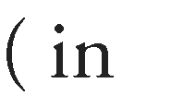
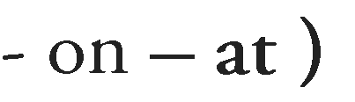
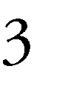

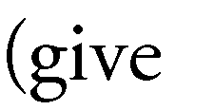
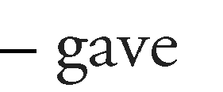
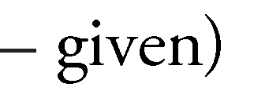
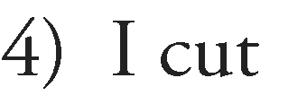



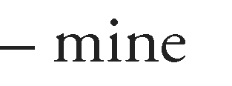
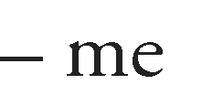
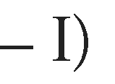
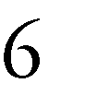
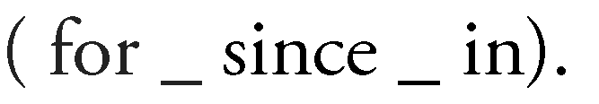
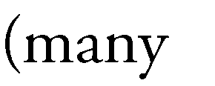
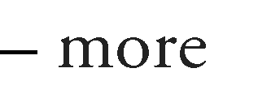
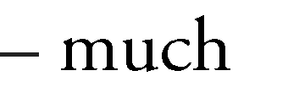
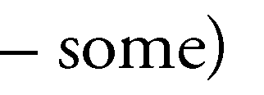
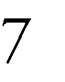
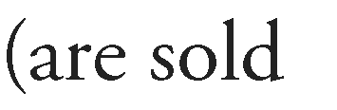
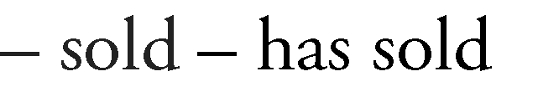
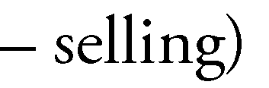




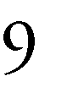
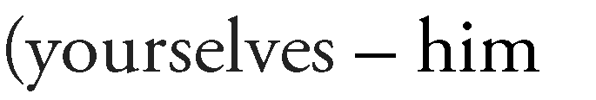
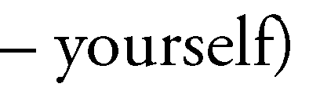

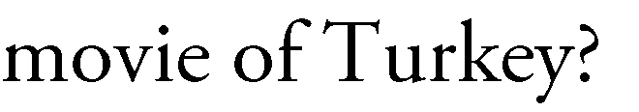

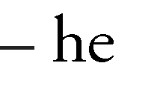
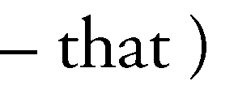
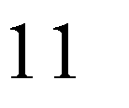

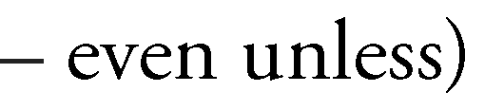
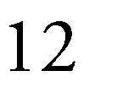
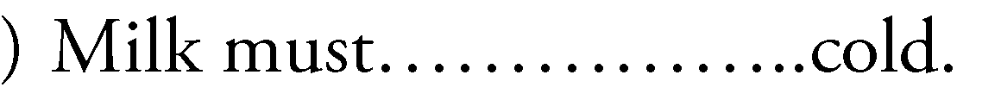

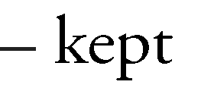

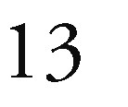






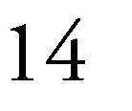
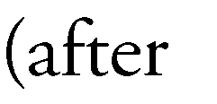
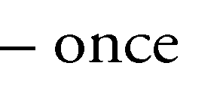
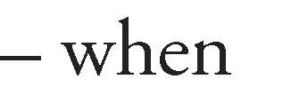
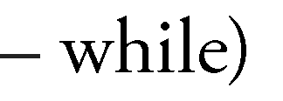
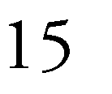
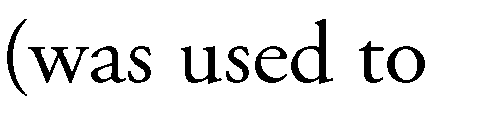
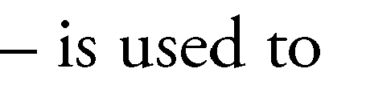
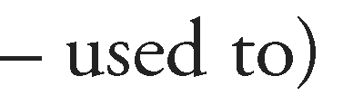
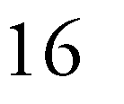


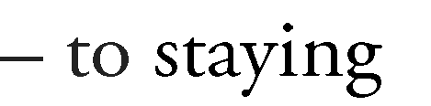
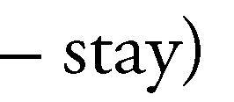
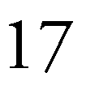

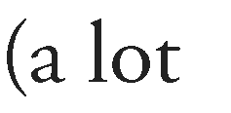
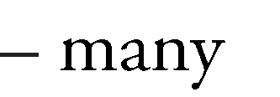
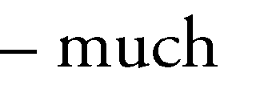
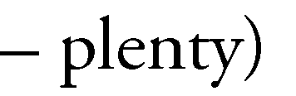
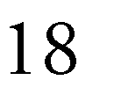

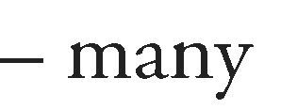
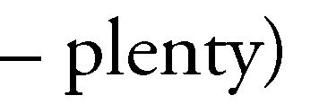
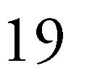

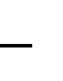

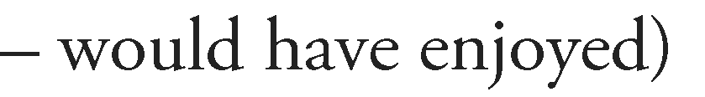
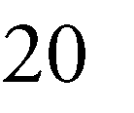


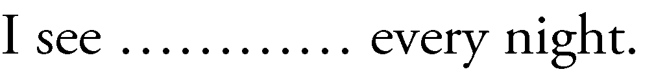

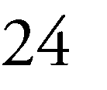

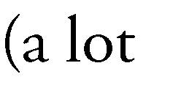
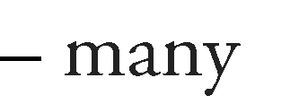
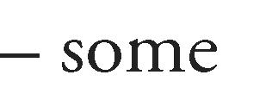

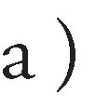







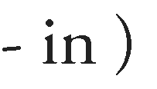
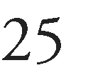

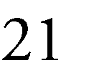

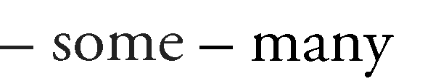
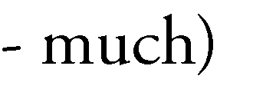
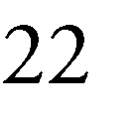
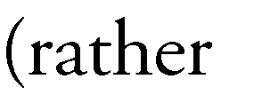
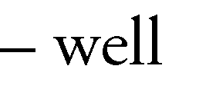
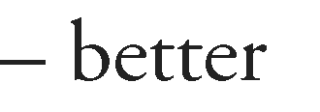
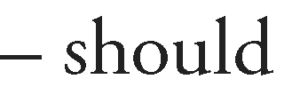
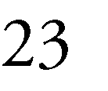

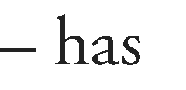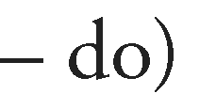

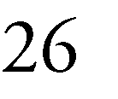


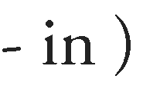

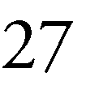

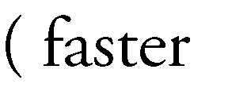
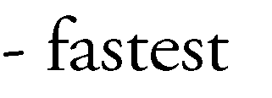

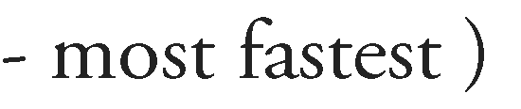
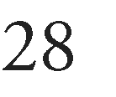


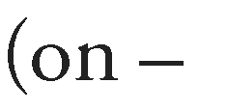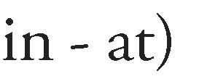
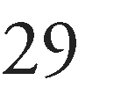

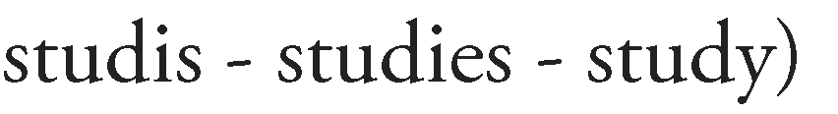
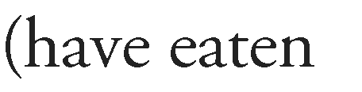

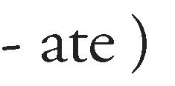
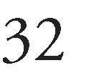




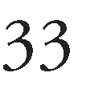
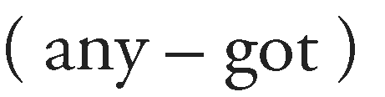

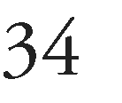
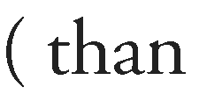





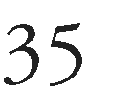





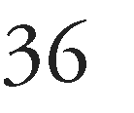

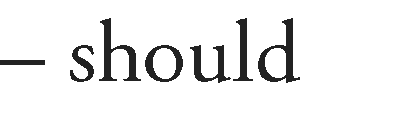
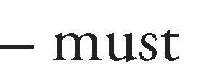



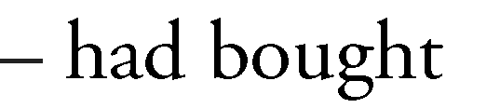
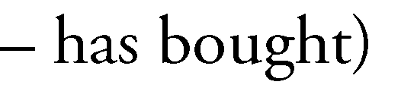



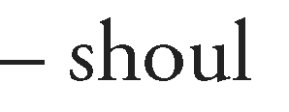
- The student to study vocabulary.

- I met my friend the afternoon.

d – must)

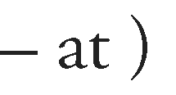
- I cut while cooking.

I)
- Milk must cold to remain fresh.
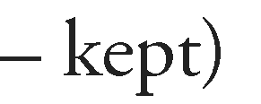

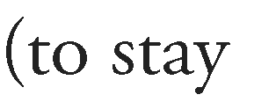

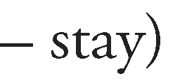
- Saud decide At home to day.

- The mechanic works on my car is very experienced.

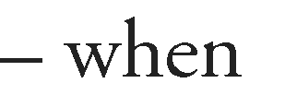
– which – is)

- King Abdul-Aziz stay in Riyadh… 1314H.

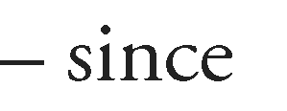

( from – in)

- I arrived, he was talking on the phone.
(after – once – when – while)

- If I had extra food, I always… it to the poor.
(give – gave – given)
- the man… I met last night was happy.
(whom – who – which)

- Ms. Amir,. the students call him Ms. Amir, thought boys physical activates

whom – which – he – him

Why don’t you let your brother
(to go )
with you to the game .

- The student prepare for his project author's books do you recommend
(which – who – that)
- Saudis like Chinese food but not as as their traditional meals.
( much _ many)

- If my father was there,………….
(would help us)

- My brother was athlete, he Before gained weight.
(was used to – is used to – used to)
- Ahmed pays the bill by his card, because he does not have… money in his wallet.

(mush – many – plenty)

- If I………….. more time, I many languages.
(have/ learn – had / had learned – had/ would learned)

- I visit king Saud library and I usually .............
(study – studying –studied –has studied)
- The city developed last few years, many new building…………..
(built – were built – have built – have been built)

- I…… visiting my parents next week? (am)
- Airplanes is than helicopters.
( faster – fastest – more faster – most fastest)
- If I go to the Paris, I visit Eiffel tower .

(will – would – be – been)

- If I………met him, I told him the truth.
(have/would - had/ would have – have / will)
- If I a doctor , I treat people for free.
( was\ will _ were\ would _ am\will ).

In which sentence is all CAPITALIZATION CORRECT?
One man wakes up every day and goes to the bus top.
That day weather was hot so he decided to buy an ice cream .He went to the super market and buy an ice cream and went home . His family was waiting for him when he back home.They are all surprised to see him with an ice cream and all they enjoyed the ice cream together .

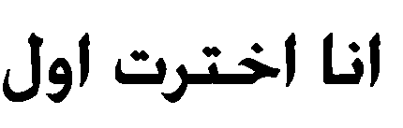









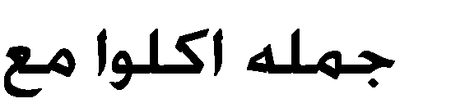






- which one of the underlined words or phrases is INCORRECT?
•
my brother explained me the math problem so I understood...

(explained – so )

  - one of the biggest problems that face many countries are the traffic

( problems_ are )

- I do it if I could, but I am already busy with something else.
(Will – can – would - shell)
- I met my friend the afternoon

( in - on – at )
- Eating ice cream is bad for my health , I eat ice cream any more.

(shouldn’t _ mustn’t _ don’t have to)

- Milk must cold to remain fresh.

(be kept – kept)
- I cut while cooking. ( myself – mine – me – I)
- Jana live……. New York, and study New York university.

(in/at – on/in – in/on – at/on)
- you play many sport ?

(do – have – has – are)

- My father died June 22

(on – at – in)

- king Abdullah became the king, he gave the women opportunities.

(since– before)

- We need… butter to make this cake.
(some – any – much - many) 12)Ahmed makes breakfast while she lunch
(is made – made – makes)
- The cake was sitting on the table when the children the class.
(enter – entered – entering)

- Jeddah on red sea.
(located – is located)

- If my father was there,………….
(would help us)

- Saud decide At home to day.
(to stay – to staying – stay)

- Have… of seeds and plants in their garden.
(a lot – many – much – plenty)

- King Abdul-Aziz stay in Riyadh… 1314H.
(for – since – to – from – in)

- I arrived, he was talking on the phone.
(after – once – when – while)

- I prepare for my project author's books do you recommend
(which – who – that)
- A: it is Eric’s?

B: Yes,… (it is his – it

- The City developed last few years, many building ……………
(built – were built – have built – have been built)

- My mother and ……will finish shopping and then take taxi.
(me- mine - I - myself)
- Peter………at seven o'clock.
(gets up- is get up)
- Carla To the radio all morning.
(had listen – listened)
- Do you know what ?
(time it is – time is it)

- I…… visiting my parents next week? (am)

